
THE BHARAT SCOUTS & GUIDES NATIONAL TRAINING CENTRE, PACHMARHI (M.P)-461881
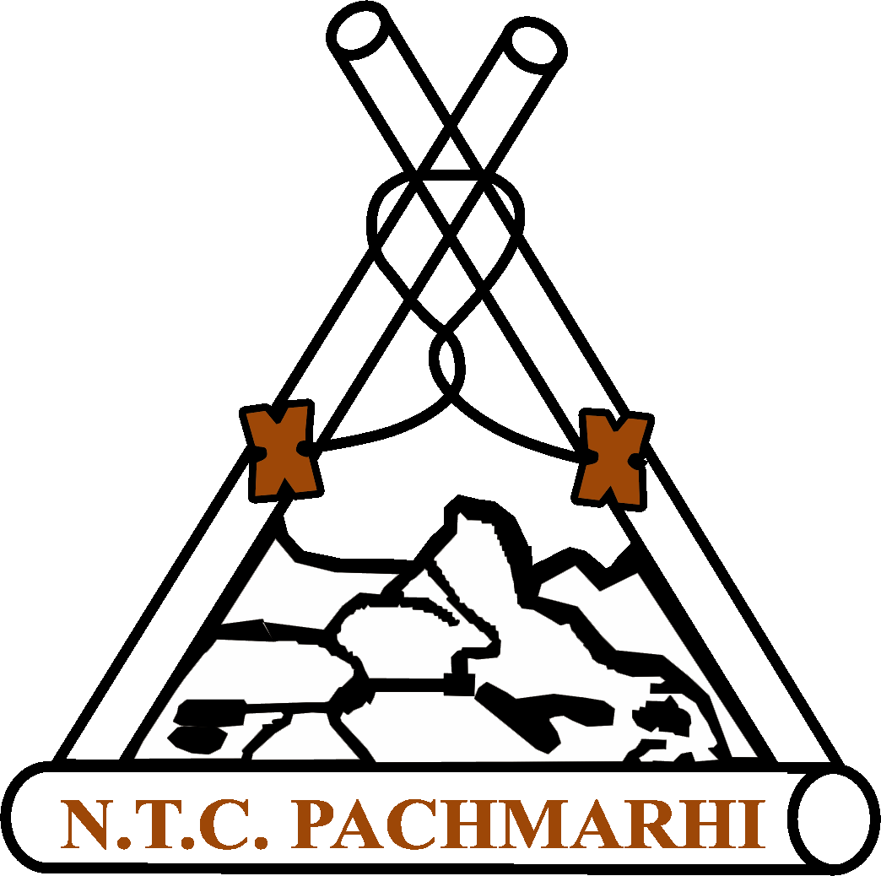
Ph. No. 07578-252026(O), Fax No. 07578-252541-E – Mail guidetrainig@bsgindia.org

Circular No.02 /2020-21 /859 Dated: 14.01.2021

To,
All the State Secretaries
State Associations of
Bharat Scouts and Guides
INDIAN UNION

Sub: 58th ALT Course (Guide Wing) from 22nd to 28th February 2021 at NTC, Pachmarhi.- Self-Financed Bases

Sir / Madam,

The Bharat Scouts and Guides National Training Centre, Pachmarhi is going to be organized ALT (GW) course on self-financed bases to cover the expenses of the course as no Government grant is available.

1 | Name of the Course | 58th ALT Course (Guide Wing)
2 | Date of the Course | 22nd to 28th February 2021 (SEVEN DAYS)
3 | Venue | Bharat Scouts and Guides National Training Centre, Pachmarhi
4 | Arrival | On 21.02.2021 evening or before 9:00AM on 22.02.2021
5 | Departure | 28.02.2021 evening after 4:00 PM (Accordingly return journey reservation may be done).
6 | Registration | Registration 10:00 AM on 22.02.2021 in proper uniform. Late comers will not be admitted for any reason
7 | How to Reach | Pachmarhi is located on the Mumbai Jabalpur route (Between Itarsi and Jabalpur Station). Pipariya is the nearest Railway station from Pachmarhi. The distance from Pipariya to Pachmarhi is 56 k.m. Buses are available from Pipariya to Pachmarhi. Number of private jeeps are also available on nominal rate. The Bharat Scouts & Guides is just 5 k.m. from Pachmarhi bus stand. Local Conveyance available to reach National Training Centre from Pachmarhi Bus Stand. Those who are coming by private Jeep can directly come up to Bharat Scouts & Guides, NTC (Queenie Park).
8 | Fee | Participants have to pay Rs. 2000 /- to meet out the expenses of the course.
9 | Financial  Assistance | Self Financed. The candidates who are interested to apply can deposit the amount in favour of ‘Bharat Scouts & Guides, Pachmarhi
10 | Mode of Payment | Online transfer / Bank Deposit:  - SBI, Pachmarhi A/c No. 11265122084  - IFS Code of SBI Pachmarhi is ‘SBIN0001046’ OR  Candidates can pay by SBI Collect (Circular attached)
11 | COVID Precaution | - The admission to course will be subject to fulfilling Covid – 19 health precautions.  - Candidates has to submit Covid-19 Test report / certificate on arrival at NTC Campsite.  - Covid test to be done within 03 days before departure.  - Face Mask is compulsory.
12 | Eligibility | The candidates: ….  - Should be able to work in a team  - Must have the experience of at least one year after the completion of Pre – ALT course successfully and run the unit effectively. A certificate to this effect is to be submitted along with application for the course.  - Should assist for the whole duration at least one Basic / Advanced course after Pre – ALT course of the concerned section.  - Should complete the pre – course assignments provided by the National Training Centre.
13 | Pre – Course Assignment | - 50 B.P. Sayings ( in the form of a booklet A₄ Size)  - 50 objectives type questions with answers each from Scouting for Boys and WAGGGS ( separately in the form of a booklet A₄ Size)  - 05 anecdotes from Scouting for Boys & 05 Anecdotes from Life Story of B.P (Hand written in the form of a booklet separately A₄ Size).  To be submitted at the time of registration
14 | What to Bring | Usual camp kit, 2 sets of correct & complete Uniform as per APRO III  Personal medicines if any, Warm Cloths and Bedding, Sleeping Bag, Torch, Odomos tube, Chart paper, Pen Pencil, Marker Pen, Note Book, Books- APRO – I & III, SOT (GW),WAGGGS etc. Knotting Rope 3 mtrs. Etc.
15 | Last Date for Application | 05.02.2020 at NTC, Pachmarhi: Late & incomplete applications will not be entertained.

The application has to reach National Training Centre Pachmarhi on or before 05.02.2021 the last date along with the copies of the certificates duly recommended by concerned state officials.

NTC will be issued the Final information on First come First Serve Bases.

Participants “Should Not’ proceed for the course without receiving the ‘FINAL INFORMATION LETTER’ from NTC Pachmarhi. Candidates bringing application by hand will not be admitted. Candidates will not be allowed to bring children / escorts with them.

Thanking you
Yours Sincerely

(Shivangi Saxena)
I/c Assistants Director (Guide Trg.)
National Training Centre, Pachmarhi
Encl:
- Application Form
- Progress Report of the Unit.
- Unit Running Certificate.
- SBI Collect Circular

Copy to:
- All the NHQ Bearers
- All the Assistant Directors of the Region for follow up.
- All the State Training Commissioners (G) for necessary action.

THE BHARAT SCOUTS & GUIDES, NATIONAL TRAINING CENTRE, PACHMARHI { M.P. } – 461881
Ph. No. 07578 – 252026 (O), 252153 (R), Fax No. 07578 – 252541 - E-Mail guidetaining@bsgindia.org, ntc@bsgindia.org

Application for Admission to ALT Course (Guide Wing)

Name of the State Association : -------------------------------------------------------------------------
Course Date : From : ………………... to ………………… Place : ………………………………..
Section : Bulbul / Guide / Ranger
Aadhaar No. ……………………………………
1. Full Name (In Block Letters) : ________________________________________________

2. Full Postal Address : ________________________________________________
________________________________________________
________________________ Pincode : ___________
E-mail ID : …………………………… Mob./Ph No. ____________________________________
3. Date of Birth : __________________ (……..Year,…… Month,….…Day)

4. Educational Qualification :………………………………………………………………….

5. Name of the Running Group : ………………………………………………………………………..
Charter No. ……………………… Date : …………. Renewed upto : …………….
- Service in the Movement as an Adult : Warrant No ………………. Date ………….. Renewed upto ………………..
Rank ……………………… Year. ……………………………..
7. Details of Training Courses Attended:

Sl | Name of the Courses | Dates |  | Venue | Certificate No & Date | Name of the LOC
Sl | Name of the Courses | From | To | Venue | Certificate No & Date | Name of the LOC
1 | Basic Course
2 | Advanced Course
3 | HWB Course
4 | Pre-ALT Certificate

8. H.W.B. Parchment No. : Date : Section

9. Course assisted as a full time staff in the Training Courses after completing Pre - ALT:
Sl No | Name of the Course | Venue | Date |  | Leader of The Course
Sl No | Name of the Course | Venue | From | To | Leader of The Course
1
2

10. Any Special interest / skill.

Above information are found correct :

Signature of applicant
Recommended
District Training Commissioner (G) STC (Guide)
Date : ____________
State Secretary/Jt.Secretary State Commissioner(G)

Date : ____________ Date : ____________
Encl.:
- Progress Report.
- Unit Running Certificate.
- Course assisted certificate.

FORM 16
Progress Report of Unit
( Guide Wing )

- Name of the State : …………………………………………...
- Name of Unit : …………………………………………………
- Name of Unit Leader : ………………………………………..
- Group Charter No. …………………………… Date ……..……….. Copy attached.
- Warrant No. …………………………………... Date …………….... Copy attached.
- Progress chart are given below (After receiving the Parchment) :

Sl | Number of Bulbul / Guide / Ranger |  | As on
Sl |  |  | 01.04.20……. | 01.04.20…… | 01.04.20….
1 | Pravesh
2 | Komal Pankh / Pratham Sopan / Praveen
3 | Rajat Pankh / Dwitiya Sopan / Nipun
4 | Swarn Pankh / Tritiya Sopan
5 | Heerak Pankh / Rajya Puraskar
6 | Golden Arrow / Rashtrapati Guide / Rashtrapati Ranger
7 | Numbers of Bulbuls / Guides / Rangers Trained Under FBM / STV/Surf Smart
8 | Total

9 | Details of Courses / Events :

a. | District level
Sl | Name of the Event | Venue | Dates |  | No attended
 |  |  | From | To
I
Ii
Iii

b. | State level
Sl | Name of the Event | Venue | Dates |  | No attended
 |  |  | From | To
I
Ii
Iii

c. | National level
Sl | Name of the Event | Venue | Dates |  | No attended
 |  |  | From | To
I
Ii
Iii

d. | International level
Sl | Name of the Event | Venue | Dates |  | No attended
 |  |  | From | To
I
Ii

It is to certify that above information are correct and her unit is running effectively.

Dist. Org. Commissioner (G) Dist. Trg. Commissioner (G) Dist. Commissioner (G)

District : District : District :

UNIT RUNNING CERTIFICATE

This is to certify that Ms. / Mrs. ……………………….……………………………… Flock Leader / Guide Captain / Ranger Leader of (Name of the Unit) …………………….................…………………………………………………….…. Her Warrant No. is . ………...…………....……………….. dated …………………. and Group Charter No. is …………………………………….…..… dated ………………. She is running the Unit effectively.

Dist. Org. Commissioner (G) Dist. Trg. Commissioner (G) District Commissioner (G)

